Implementation (Coding)

🌟 Definition
# Source: AI Source: Provided by: [Data Path: Persons Table -> ID Column: 1, Name_En Column: Motasem Essam] -> From: [ChatGPT] on [6/7/2026]
Implementation (Coding) is the fourth phase of the Software Development Life Cycle (SDLC) where developers write the actual source code based on the system design documents.
The main question in this phase is:
"How do we build the software according to the design?"

🎯 Purpose of Implementation Phase
# Source: AI Source: Provided by: [Data Path: Persons Table -> ID Column: 1, Name_En Column: Motasem Essam] -> From: [ChatGPT] on [6/7/2026]
The goals of implementation are to:
- Convert design into working software
- Develop application features
- Create databases and APIs
- Integrate system components
- Produce executable software

🔄 Implementation Process
# Source: AI Source: Provided by: [Data Path: Persons Table -> ID Column: 1, Name_En Column: Motasem Essam] -> From: [ChatGPT] on [6/7/2026]
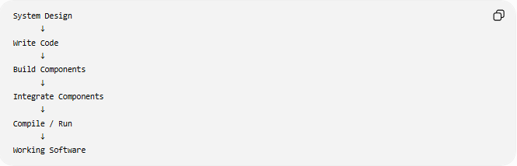
System Design
↓
Write Code
↓
Build Components
↓
Integrate Components
↓
Compile / Run
↓
Working Software

🧩 Main Activities in Implementation

1️⃣ Setting Up the Development Environment
# Source: AI Source: Provided by: [Data Path: Persons Table -> ID Column: 1, Name_En Column: Motasem Essam] -> From: [ChatGPT] on [6/7/2026]
Definition
Prepare the tools needed for coding.

Examples
Programming Languages
- PHP
- Java
- Python
- JavaScript
- C#

Code Editors / IDEs
- Visual Studio Code
- IntelliJ IDEA
- PyCharm

Databases
- MySQL
- PostgreSQL

Local Servers
- XAMPP
- WampServer

2️⃣ Writing Source Code
# Source: AI Source: Provided by: [Data Path: Persons Table -> ID Column: 1, Name_En Column: Motasem Essam] -> From: [ChatGPT] on [6/7/2026]
Definition
Developers write code according to the design specifications.

Example
PHP:
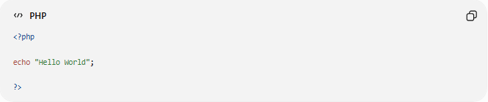
<?php
echo "Hello World";
?>
Output:
Hello World

Example
JavaScript:
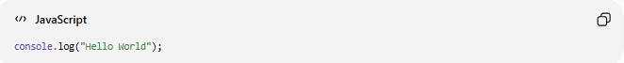
console.log("Hello World");

3️⃣ Database Development
# Source: AI Source: Provided by: [Data Path: Persons Table -> ID Column: 1, Name_En Column: Motasem Essam] -> From: [ChatGPT] on [6/7/2026]
Definition
Create databases, tables, relationships, and constraints.

Example
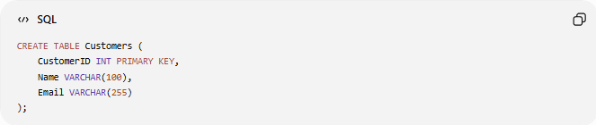
CREATE TABLE Customers (
CustomerID INT PRIMARY KEY,
Name VARCHAR(100),
Email VARCHAR(255)
);

Insert Data
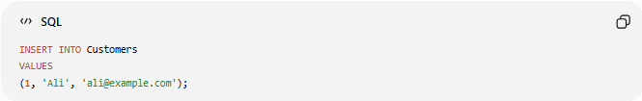
INSERT INTO Customers
VALUES
(1, 'Ali', 'ali@example.com');

4️⃣ Module Development
# Source: AI Source: Provided by: [Data Path: Persons Table -> ID Column: 1, Name_En Column: Motasem Essam] -> From: [ChatGPT] on [6/7/2026]
Definition
Build individual system components.

Example:
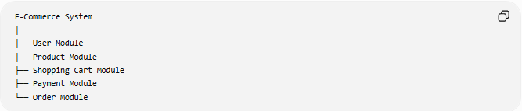
E-Commerce System
│
├── User Module
├── Product Module
├── Shopping Cart Module
├── Payment Module
└── Order Module
Each module is developed separately.

5️⃣ API Development
# Source: AI Source: Provided by: [Data Path: Persons Table -> ID Column: 1, Name_En Column: Motasem Essam] -> From: [ChatGPT] on [6/7/2026]
Definition
Create interfaces that allow systems to communicate.

Example:
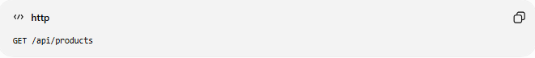
GET /api/products
Response:
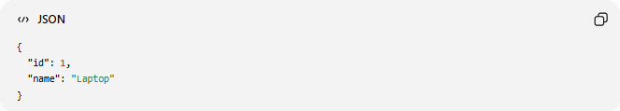
{
"id": 1,
"name": "Laptop"
}

6️⃣ Integration
# Source: AI Source: Provided by: [Data Path: Persons Table -> ID Column: 1, Name_En Column: Motasem Essam] -> From: [ChatGPT] on [6/7/2026]
Definition
Combine modules into a complete system.

Example:
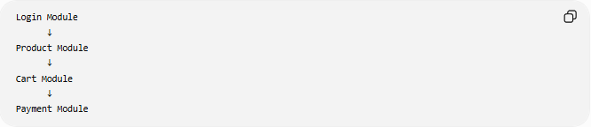
Login Module
↓
Product Module
↓
Cart Module
↓
Payment Module
All modules work together.

7️⃣ Code Review
# Source: AI Source: Provided by: [Data Path: Persons Table -> ID Column: 1, Name_En Column: Motasem Essam] -> From: [ChatGPT] on [6/7/2026]
Definition
Developers inspect each other's code to improve quality.

Checks include:
- Coding standards
- Performance
- Security
- Readability
- Maintainability

Example:
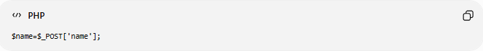
$name=$_POST['name'];
Improved version:
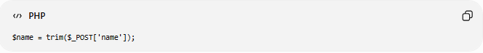
$name = trim($_POST['name']);

8️⃣ Unit Testing During Coding
# Source: AI Source: Provided by: [Data Path: Persons Table -> ID Column: 1, Name_En Column: Motasem Essam] -> From: [ChatGPT] on [6/7/2026]
Definition
Developers test individual functions and modules while coding.

Example:
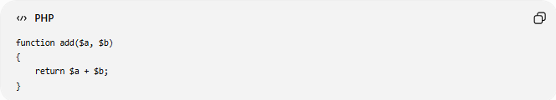
function add($a, $b)
{
return $a + $b;
}
Test:
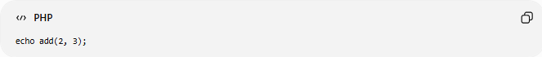
echo add(2, 3);
Expected:
5

📚 Coding Standards
# Source: AI Source: Provided by: [Data Path: Persons Table -> ID Column: 1, Name_En Column: Motasem Essam] -> From: [ChatGPT] on [6/7/2026]
Good implementation follows:
Naming Conventions
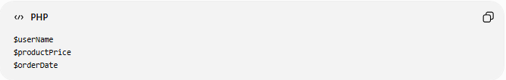
$userName
$productPrice
$orderDate

Comments
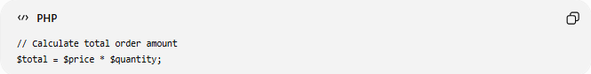
// Calculate total order amount
$total = $price * $quantity;

Indentation
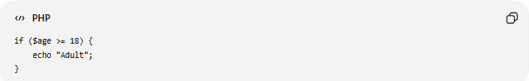
if ($age >= 18) {
echo "Adult";
}

🛠️ Tools Used During Implementation
# Source: AI Source: Provided by: [Data Path: Persons Table -> ID Column: 1, Name_En Column: Motasem Essam] -> From: [ChatGPT] on [6/7/2026]
Version Control
Used to manage source code.
Examples:
- Git
- GitHub
- GitLab

Package Managers
Examples:
- Composer (PHP)
- npm (JavaScript)
- pip (Python)

Frameworks
Examples:
- Laravel
- Django
- ASP.NET Core

📊 Output of Implementation
# Source: AI Source: Provided by: [Data Path: Persons Table -> ID Column: 1, Name_En Column: Motasem Essam] -> From: [ChatGPT] on [6/7/2026]
At the end of this phase:
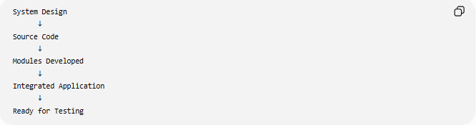
System Design
↓
Source Code
↓
Modules Developed
↓
Integrated Application
↓
Ready for Testing

🌍 Real-World Example
Online Store
During implementation developers create:
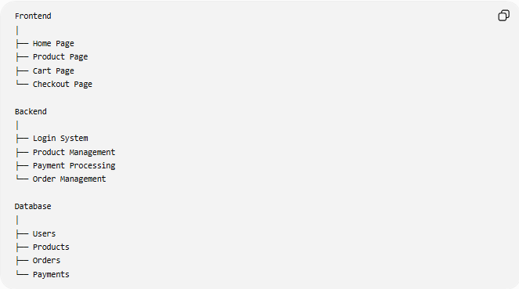
Frontend
│
├── Home Page
├── Product Page
├── Cart Page
└── Checkout Page
Backend
│
├── Login System
├── Product Management
├── Payment Processing
└── Order Management
Database
│
├── Users
├── Products
├── Orders
└── Payments

📊 Common Deliverables
# Source: AI Source: Provided by: [Data Path: Persons Table -> ID Column: 1, Name_En Column: Motasem Essam] -> From: [ChatGPT] on [6/7/2026]
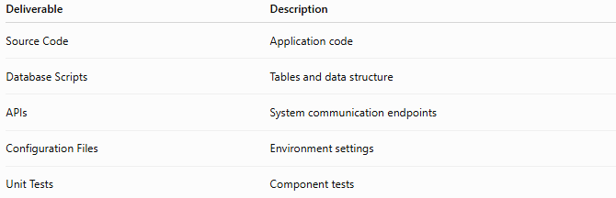
Deliverable | Description
Source Code | Application code
Database Scripts | Tables and data structure
APIs | System communication endpoints
Configuration Files | Environment settings
Unit Tests | Component tests

🧠 Simple Analogy
# Source: AI Source: Provided by: [Data Path: Persons Table -> ID Column: 1, Name_En Column: Motasem Essam] -> From: [ChatGPT] on [6/7/2026]
Building a house:
Implementation Phase
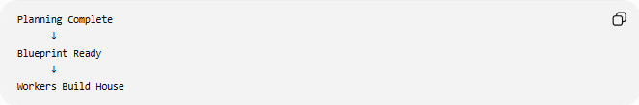
Planning Complete
↓
Blueprint Ready
↓
Workers Build House
Software equivalent:
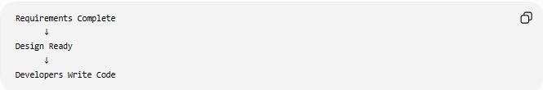
Requirements Complete
↓
Design Ready
↓
Developers Write Code
This is where the actual product is constructed.

🧭 Summary
# Source: AI Source: Provided by: [Data Path: Persons Table -> ID Column: 1, Name_En Column: Motasem Essam] -> From: [ChatGPT] on [6/7/2026]
The Implementation (Coding) Phase is the SDLC stage where developers transform the system design into working software by writing source code, creating databases, building APIs, developing modules, integrating components, and performing initial testing. The output of this phase is a functional application ready for formal testing.

